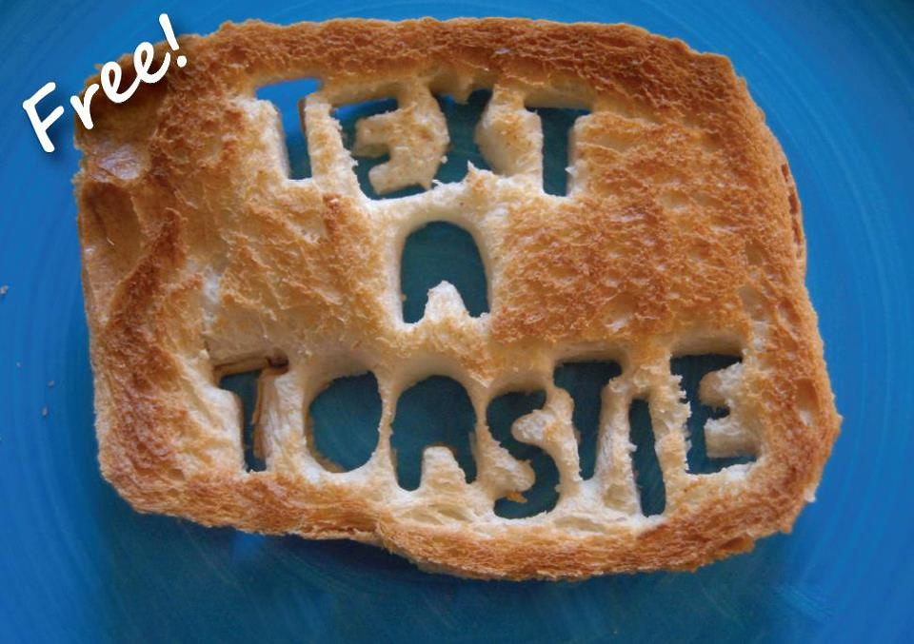

Get a free toastie from InterVarsity Christian Fellowship on Thursday, November 14 from 8:00-10:00pm. All you have to do is text (608) 123-4567 with your…

**question:** Any question about God, Jesus, Christianity, etc. We’ll do our best to  
 answer it when we deliver your toastie.

**flavor:** Cheese or nutella.

**location:** Where to deliver (on campus only).

**Thursday, Nov. 14th**

**8:00-10:00pm**

**(608) 123-4567**

**toastie:** (noun) \ˈtō-stē \ a delicious toasted sandwich, traditionally filled with cheese or nutella